**Conservation and Wildlife Report for Year to May 2024 for**

**Burrow Hill Nature Reserve**

**General.**

For future reference this report will be stored at [Home | Keaver Drive Management Company](https://www.keaverdrive.co.uk/)

As owners and guardians of Ancient Woodlands, we are working with the Forestry Commission on a 10 year management plan which is an important step forward and raises awareness of our woodlands and its importance. We are now in our second year of creating the plan and it becomes official only after the Forestry Commission approve it. More details to follow in subsequent reports.

The wildlife pond in the HA area at the bottom of the estate has silted up again as the netting holding the majority of the leaves back was removed. It’s a shame that this pond is not able to provide a watering sanctuary for our wildlife. Another attempt at recovering it back to use may be made in the near future. The newer woodland pond behind #36 continues to attract mammals and birds to use it for its purpose as a watering hole. Small pond life is also continuing to thrive.

New tree planting and building of bee homes continues. This year we have lost some small established sweet chestnut trees on the edges of the woodlands at the top of the path but in return have planted some English oak, yew, sycamore and sweet chestnut, in areas where they are able to get sun and rain on the woodland edges. In the next year given time, two trial growing areas will be established within the woods. We plan to clear the holly canopy to allow light and rain to the woodland floor. We will allow the seed bank contained in our woods to grow and plant native species of trees in these trial areas.

We had a very unusual visitor to the SANGS in early spring. The Large Tortoiseshell butterfly is considered extinct in this country, having been designated extinct in the 1980s due to habitat loss and use of pesticides. However some do make their way to these islands from the continent and we had one visit us in March. A very rare find reported to the Surrey and National butterfly recorders. More on this later.

**Birds.**

Many bird species use our woodlands for home, rest and food. We now have over 80 species recording in or over the woodlands, meadow and SANGS. This is a great count given how small it is, how urban it is and how surrounded by housing it is. Being close to Frith Hill woods does help but as that area is mostly planted with fir for wood production, it doesn’t really attract many of our native bird species which need mature, native trees and bushes to survive and thrive.

The key bird species we’ve had here over the winter have been Siskin and Redpoll. Both have been extensively seen across Southern England and our woods are no exception. Photos below give an idea of these lovely birds, along with chaffinches, nuthatches, long tailed and other members of the tit family that use garden feeders when the seeds on the birch and beech trees have run out, so we have been fortunate to see and get close to them this year.

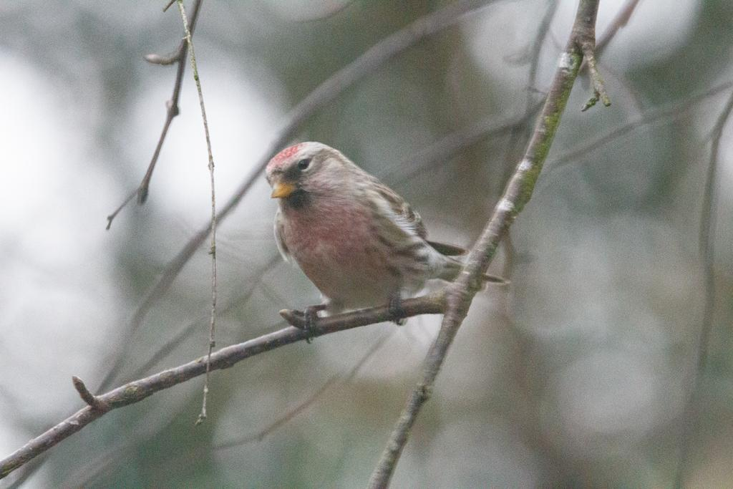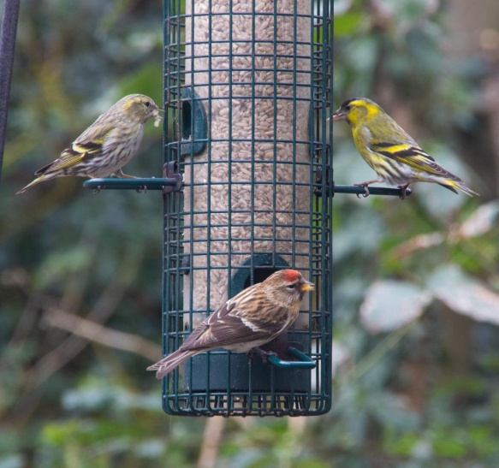

Figure - Lesser Redpoll (courtesy of Dan #24) Figure - Lesser Redpoll and Siskins feeding together (Dan)

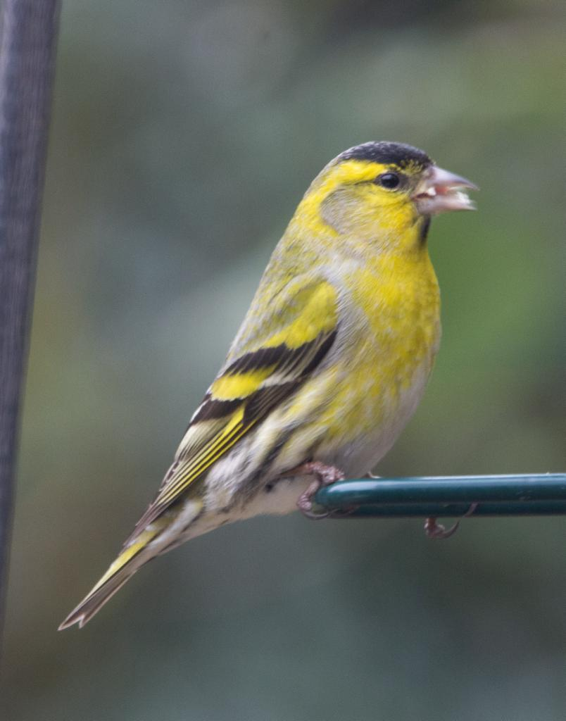

Figure - Beautiful male Siskin (Dan)

We’ve also had a male Tawny Owl calling from our woodlands almost every day. What’s unusual is he is calling in the day as well as at night. This suggests he is territorial and possibly means he has a mate in the nest box sitting on eggs. We don’t know whether this is the case or not until the owlets emerge from the nest box and “branch” into the oak trees, where the parents will feed them until they fledge. Fingers crossed as the nest box has been there now for a few years and it would be great to think we are helping the Tawny Owl population.

Firecrest numbers are still good even though the migrating Scandinavian birds have gone back home for their summer breeding. We added 1 new species to the nature reserve list. The Redpolls come in several species and subspecies. All the ones we’ve seen in the birch trees and on our garden feeders are Lesser Redpolls, native to Britain and breeds here in good numbers. Among them on one occasion was a Common Redpoll (aka Mealy Redpoll), which unlike its name is not common at all. They come over from the continent in small numbers most years and differ from the Lesser by being larger and whiter, so finding one here was great. Other birds of note are our established green woodpecker nesting pair and a calling wood warbler in the spring on passage to the west and north of the UK where they breed.

We have recorded 14 breeding species this year, 15 if the Tawny Owls have young. Helping the British populations of native and migrant birds is essential when the overall populations in the UK are dramatically reducing.

**Mammals**

Our badger population clan continues to be here even though the pressures to move away are always there. It is estimated we are down to about 6 individual animals. 4 have been seen together including a cub, so again breeding has been successful in our reserve. The latest survey had 4 active entrances near the main sett on the South side of the woodlands. No other entrances were found to be active during the survey so it was a surprise when Ian (#42) sent video of adults and a cub in a sett directly behind his garden on the North side. Badgers are clever at covering up the entrances to breeding chambers as a method of deterring predators.

A neighbour in Carisbrooke is allowing dogs to run free in our woods. This has the effect of scaring the badger clan away from here. If anyone sees or hear dogs in the woods, please contact Paul.

As Paul is the Camberley area Field Officer for WSBG (currently dealing with a number of badger related incidents incuding one of our neighbours in Braemar Close) please report any sightings or concerns to him directly, or through the WSBG office number on 07726 929681.

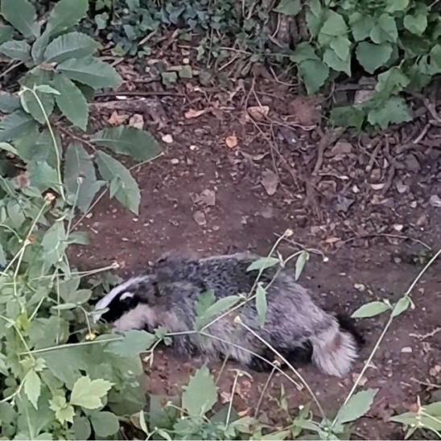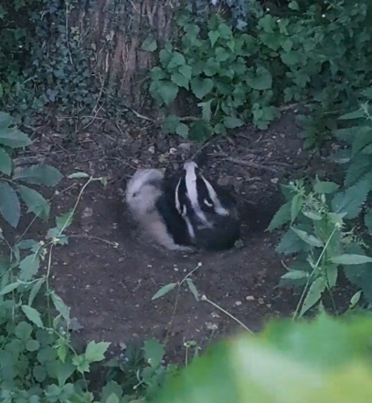

Figure - Badger cub (courtesy of Ian #42) Figure - Bader sow having a scratch (Ian )

Red foxes continue to do well, new families of cubs have been recently seen this spring with several adult pairs are resident in our reserve. We have counted 4 cubs together so far. Our fox population are generally in good condition and are managing to keep grey squirrel and brown rat numbers down.

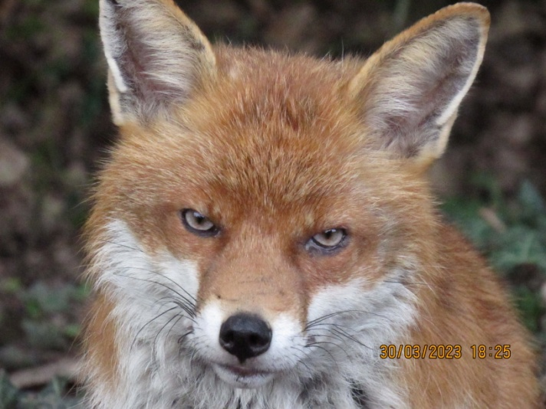

Figure – Confiding male Red Fox in our woods (Paul #32)

During a bat evening, we recorded a Barbastelle Bat, a UK wide rarity which we hoped to confirm with the Surrey Bat Recorder. A near neighbour also reported recording a Barbastelle over his garden so we were pretty confident. However the Recorder was not convinced and the species was not verified. The recording might have been an off-key Common Pipistrelle as the 2 echo location sounds are similar and they have seen confusion between these 2 species before, particularly around woodlands and buildings (similar to our environment). They asked us to rerecord and send them again, but they have not been seen since. So the species is logged as a possible.

**Other Animal and Flora News**

Our current species list stands at 1091. Our total species for all flora and fauna is broken down as follows;

|  |  |
| --- | --- |
| **Total species recorded** | 1091 |
| Flora (including fungi) | 233 |
| Fauna (including all insects) | 858 |

This is an increase of 115 over this time last year.

As mentioned earlier we had a very unusual visitor to the SANGS in early spring. The Large Tortoiseshell butterfly is considered extinct in this country, having been designated extinct in the 1980s due to habitat loss and use of pesticides. So the one found in the SANGS was very surprising and as it turned out was 1 of 3 found across the whole of Surrey this spring. After logging the sighting with the Surrey Recorder and the UK National Butterfly database it was confirmed that it was a genuine sighting rather than an unlicensed release. Unfortunately butterflies are bred at home and sometimes released into the wild where they can do damage to native populations, so it was great to hear this was not the case. Since becoming extinct, this year was the best year for them migrating in from the continent and also it was confirmed that a small breeding population has established itself at Knepp estate in Sussex. Brilliant!

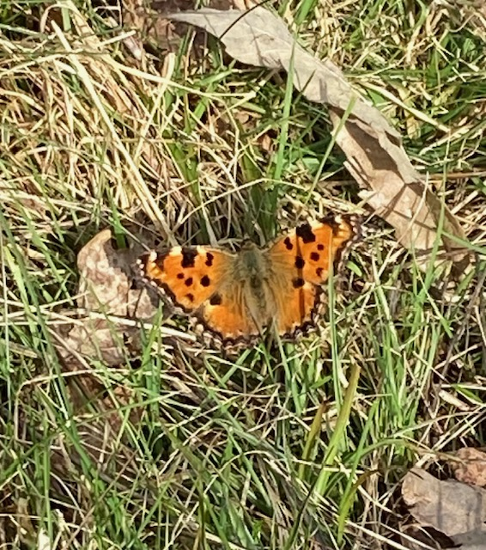

Figure - Large Tortoiseshell butterfly extinct in the UK - (Paul #32)

Another rare visitor to our woodlands was a reptile. We rarely see reptiles in our environment but a local lad saw a grass snake in a cats mouth and managed to release the snake before it could be damaged. The lad was a friend of Dan (#24) and it was decided to release the grass snake into the meadow and woodlands at the bottom of the steps.

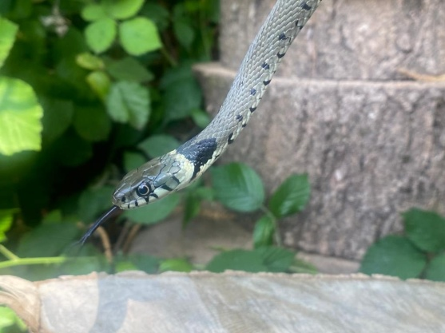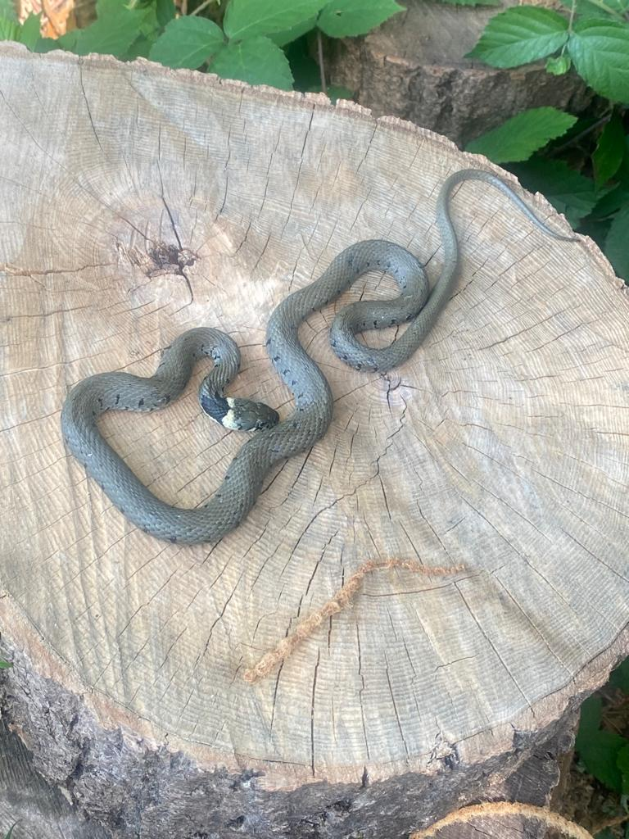

Finally some great flora news. Our first recorded Orchid was found in summer 2023 and it has reappeared this year. A single Pyramidal Orchid flower was found last year but this year 2 flowers in the same area have been found. They can be found in the meadow, near the remaining ash tree on the left just after the end of the steps and it is hoped that they will establish themselves.

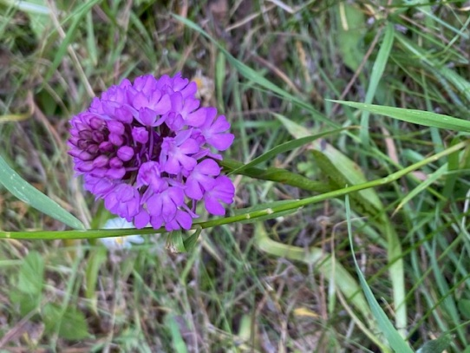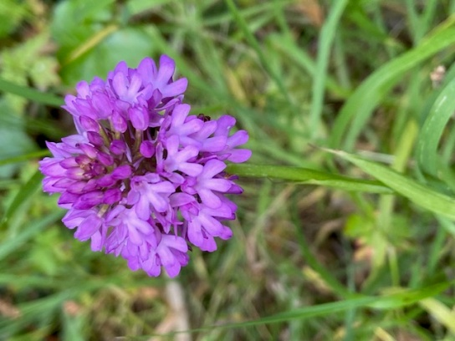

Figure - Pyramidal Orchid (Paul) Figure - Pyramidal Orchid #2 (Paul)

**Nature Reserve Update**

As reported last year the nature reserve continues to suffer from naturally caused stresses. Weather is a key concern, particularly strong winds. A large limb from an oak was felled by wind on to a neighbouring garden fence. It caused in excess of £3000 damage when adding together the clearance work and the replacement fence. A lot of time has been spent sorting this one out, but we are happy to report its all complete now.

Recently an oak decided to totally collapse down into the SANGS, on a calm day. Luckily no-one was on the path where it fell, but the clearance took over a week by SHBC and their contractors. KDFMCL have asked SHBC if there was any identified reason for the trees failure, but all they have said is stress from Climate Change and changing seasons, so it can be assumed that others may be experiencing the same stress. We will engage with our Arboriculture Consultant to take particular attention to the oaks around the estate when conducing the woodlands review.

The wildflower meadow between the steps and Buckingham Way is doing well. The grasses and wild flowers are now in full growth and attracting good numbers of pollinators. A survey of species fund there will be conducted in July/August at the peak of the season before we maintain it ready for the winter. Some large gorse bushes have been removed back to their base. They’ll grow back to refill the space left.

If anyone has interesting information of flora or fauna across the estate, please let Paul know.

**SANGS**

The recovery of the SANGS post the works is a cause for concern. There seems to be no real pan to re-establish its rich flora and special flora species lost to the work. Over 200 established trees and bushes were destroyed. We have written a letter of concern to SHBC as Esso stated the planting would be like for like and we have established a line of communication.

The Esso contractors have now completed their remedial works, reinstating the paths, benches and planting replacement trees for those they destroyed. Unfortunately they have planted tiny seedlings, surrounded them by plastic and then sprayed the area with herbicide to kill off any competing grasses and wildflowers. Not really the way to treat an area of Natural Growth!

A further 5 years of remedial work is now the responsibility of SHBC, with Esso having to pay SHBC for a 5 year plan to manage the SANGS post their destructive work, as per the planning consent. KDFMCL are in contact with the head of the Greenspace team who manage the work on the SANGS so if anyone has any concerns about that area, please let Paul know.

**Useful Information**

As for this report, all future nature reports will be placed onto the KDFMCL website for all residents to access at [Home | Keaver Drive Management Company](https://www.keaverdrive.co.uk/). Also if you have any photos of the local environment or wildlife and would like them on the website, please send them to Paul to upload. If you do not access the website or know of residents who don’t access the internet, then a paper copy can be provided. Any help required on our environment, the woodlands as well as wildlife in your gardens, please contact Paul at [thecolletts@btinternet.com](mailto:thecolletts@btinternet.com) or on 07979 708207.